O’ZBEKISTON RESPUBLIKASI MUDOFAA VAZIRLIGI HARBIY XAXFSIZLIK VA MUDOFAA UNIVERSITETINING AXBOROT-KOMMUNIKATSIYA TEXNOLOGIYALARI VA HARBIY ALOQA INSITUTI



AXBOROT-KOMMUNIKATSIYA TEXNOLOGIYALARI VA SUN’IY INTELLEKT KAFEDRASI
“Suniy intellekt asoslari” FANIDAN

MUSTAQIL ISH

Bajardi: Elmurodov H.
Qabul qildi: Isakov .

Toshkent 2025
3-topshiriq
3.1 Fileni ochish va yozish(Append): data.txt fileni oching va unga yangi satrlarni(Masalan: “Yangi satr”) qo’shing. So’ngra fileni o’qib barcha satrlarni ekranga chiqarib bering.
3.2 Filega o’qish va qatorlar sonini hisoblash: logfile.txt fileni o’qing, har bir satrni alohida chiqarib, umumiy qatorlar sonini hisoblang.

3.1-masala
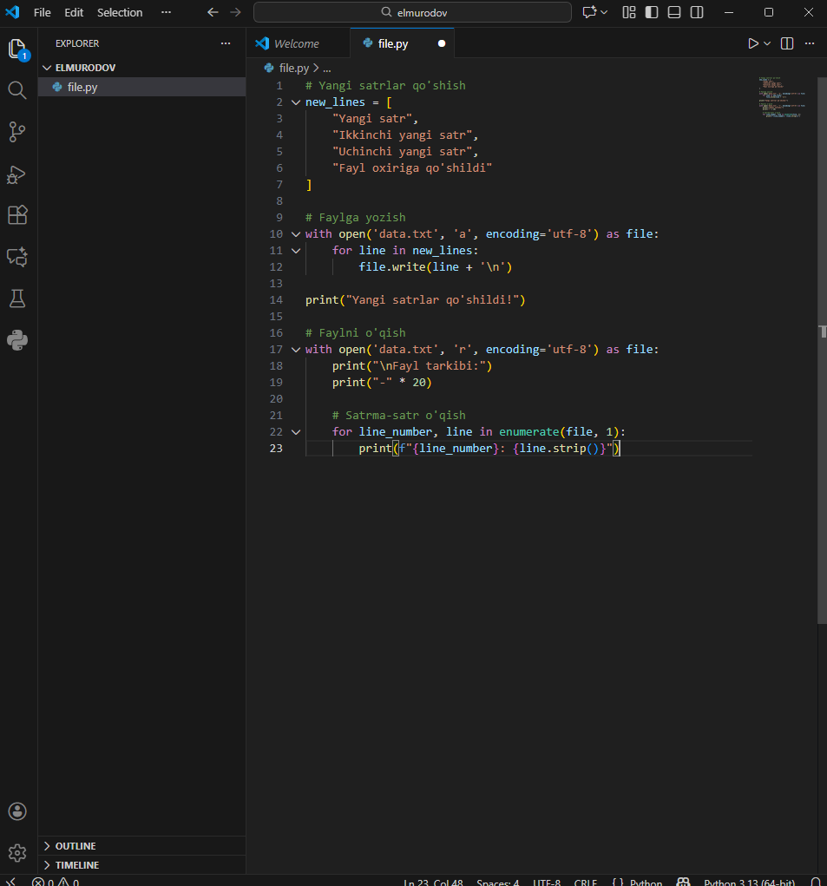
1-rasm: 3.1 masala yechimi
Yechim:
new_lines = [
"Yangi satr",
"Ikkinchi yangi satr",
"Uchinchi yangi satr",
"Fayl oxiriga qo'shildi"
]
with open('data.txt', 'a', encoding='utf-8') as file:
for line in new_lines:
file.write(line + '\n')
print("Yangi satrlar qo'shildi!")
with open('data.txt', 'r', encoding='utf-8') as file:
print("\nFayl tarkibi:")
print("-" * 20)

for line_number, line in enumerate(file, 1):
print(f"{line_number}: {line.strip()}")

3.2 Filega o’qish va qatorlar sonini hisoblash.
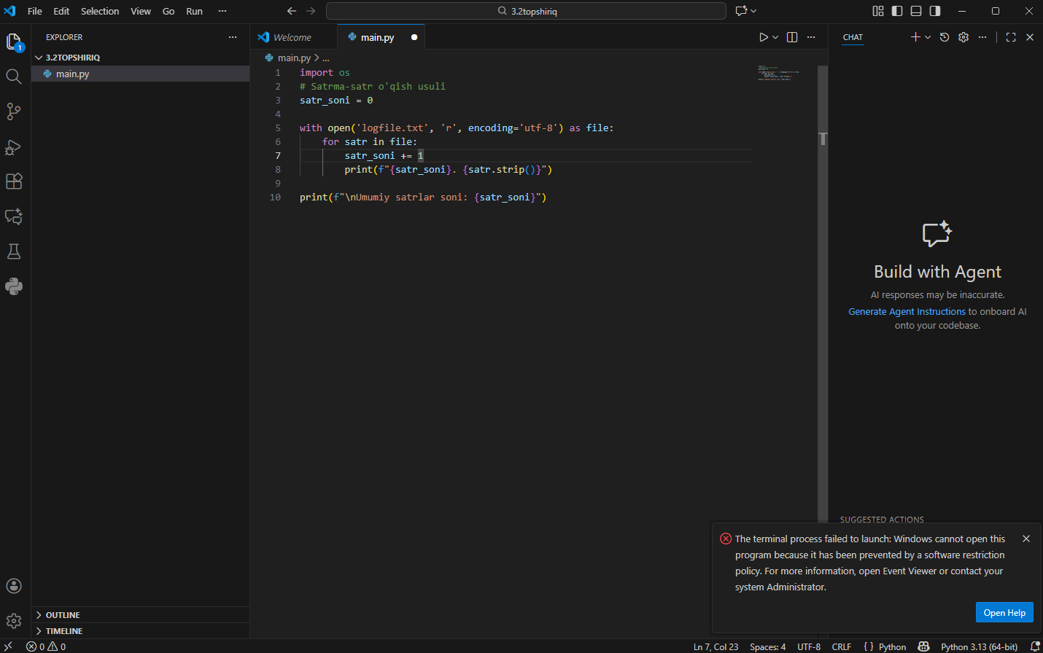
Yechim:
import os
# Satrma-satr o'qish usuli
satr_soni = 0

with open('logfile.txt', 'r', encoding='utf-8') as file:
for satr in file:
satr_soni += 1
print(f"{satr_soni}. {satr.strip()}")

print(f"\nUmumiy satrlar soni: {satr_soni}")

